Guide To Run The Scripts

Installing WebDriver

Importing a Test Project into Eclipse

Instructions to Run Test Script 01,02,03

Run the Test Script 04, 05,06

Parameters to Change before Script Run

# Installing WebDriver

* Install Java SE Development Kit 8 (or 7)
  + Download the Java SE 8 [here](http://www.oracle.com/technetwork/java/javase/downloads/jdk8-downloads-2133151.html)
  + Choose version to download: Windows 86 or x64 base on your OS ([jdk-8-windows-i586.exe](http://download.oracle.com/otn-pub/java/jdk/8-b132/jdk-8-windows-i586.exe) and [jdk-8-windows-x64.exe](http://download.oracle.com/otn-pub/java/jdk/8-b132/jdk-8-windows-x64.exe))
* Install Eclipse Indigo
  + Download the Eclipse Indigo [here](https://www.eclipse.org/downloads/packages/eclipse-ide-java-ee-developers/indigosr2), you can choose version Windows 32 bit or 64 bit
  + Extract the zip file and run
* Download Selenium Java Library [here](http://selenium-release.storage.googleapis.com/2.40/selenium-java-2.40.0.zip)
* Install TestNG framework via Eclipse
* Eclipse→ Help→ Install New Software → Click Add

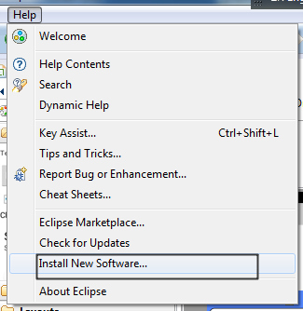

* In dialog box, enter Name: TestNG, location <http://beust.com/eclipse> ,→ click OK

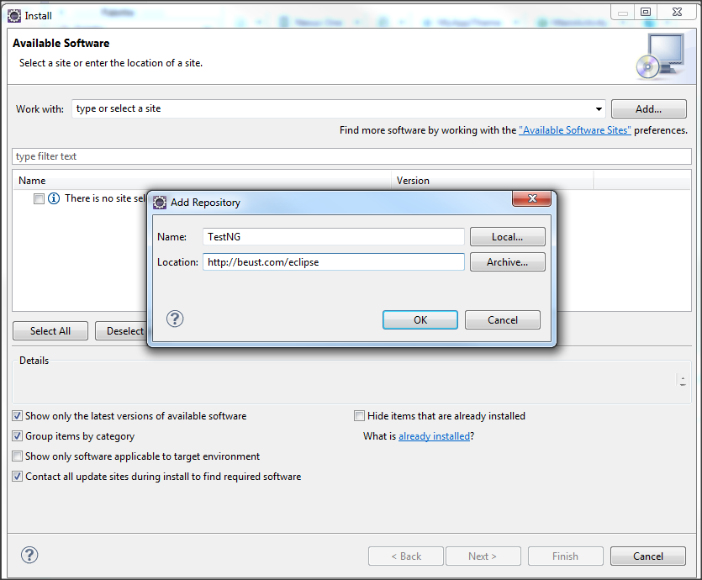

* Dialog Box is displayed as below, click Next to install→ Eclipse will then guide you through the process. (Note that for the different Eclipse version, the screen below little bit different)

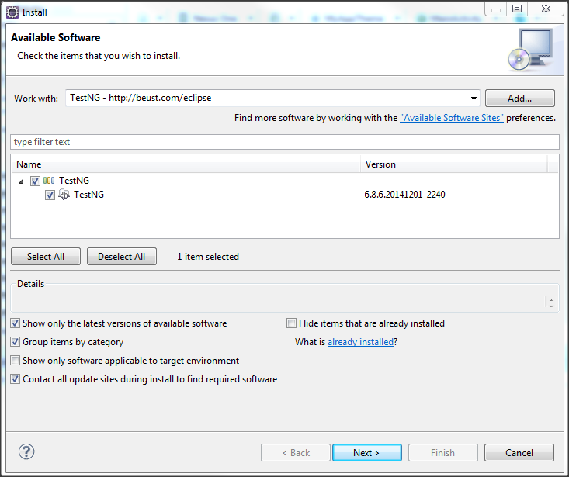

* If the installation success, Fileà New à Others, you will see the TestNG display as below

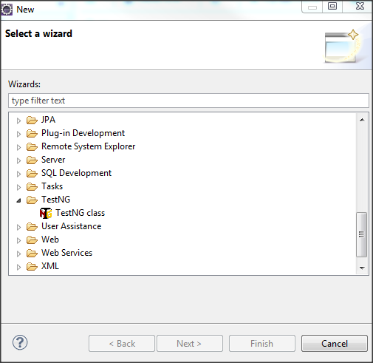

Refer this [guide](http://www.guru99.com/installing-selenium-webdriver.html) to understand Webdriver installation in more detail

Refer this [guide](http://www.guru99.com/all-about-testng-and-selenium.html) to understand TestNG installation in more detail

# Importing a Test Project into Eclipse

* Open Eclipse, File → Import→ Choose Existing Projects into Workspace → Next

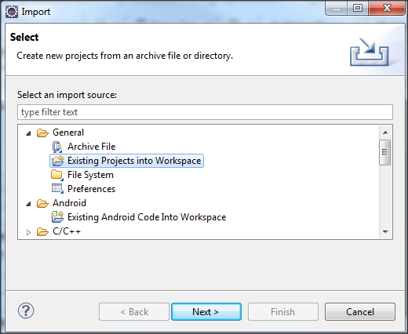

* Browse to project directory → Finish

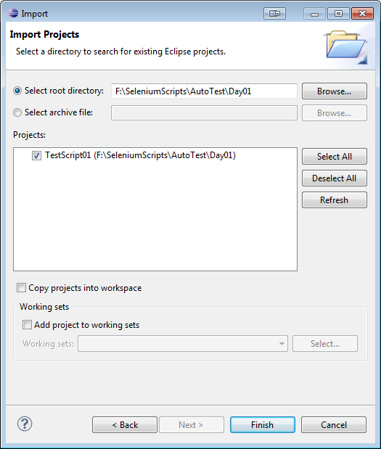

* Selenium Test project display on workspace

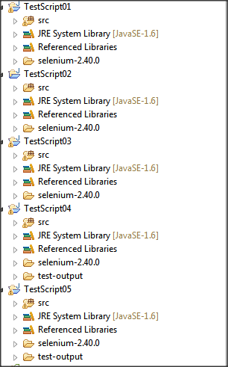

* Open Selenium folder selenium-2.40.0 included in the project. In this folder you have two jar files related to selenium and a lib folder in which you have other jar files. Refer following screenshot.

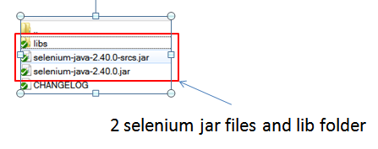

* You have to import ALL the library file to your project (This library is the **same** for **all** tests)
* Right Click project → Build Path →Configure Build Path
* Click Libraries tab
* You will see the Selenium library (already imported to project) displayed
* If no , Click Add External Jars → Select all Files in “selenium-2.40.0” & “lib” folders

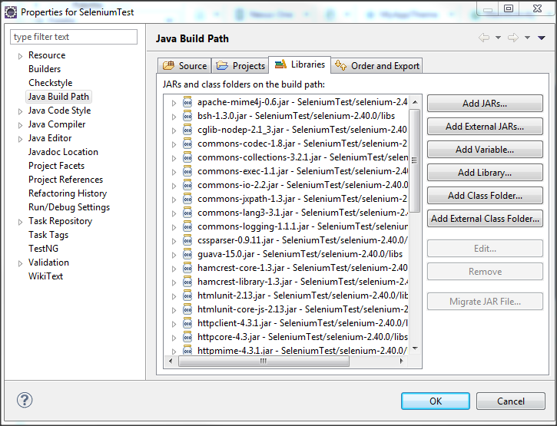

**You are done.**

# Instructions to Run Test Script 01,02,03

To Run the Test Script

Right Click file→ Run As →TestNG Test

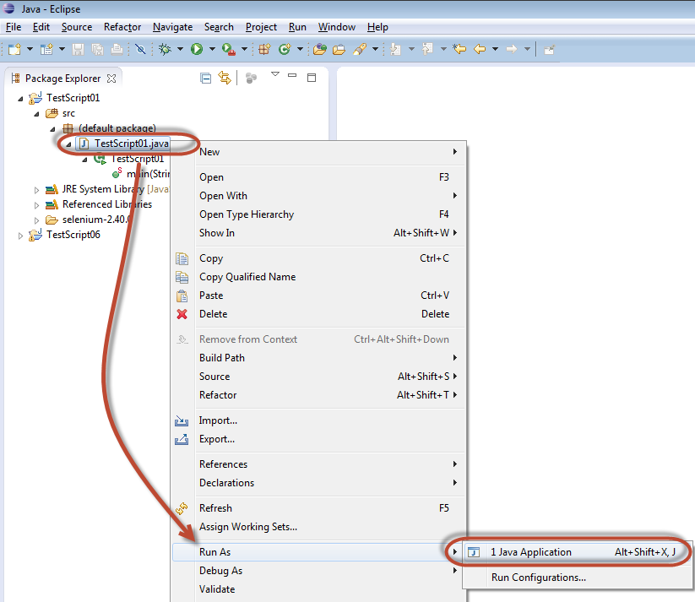

# Run the Test Script 04, 05,06

To Run the Test Script using TestNG

* Right Click file→ Run As →TestNG Test

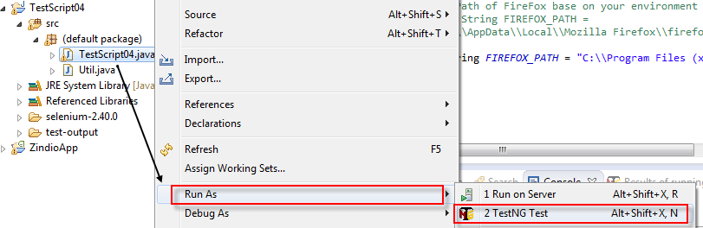

* The Script run automatically, the test result display as below

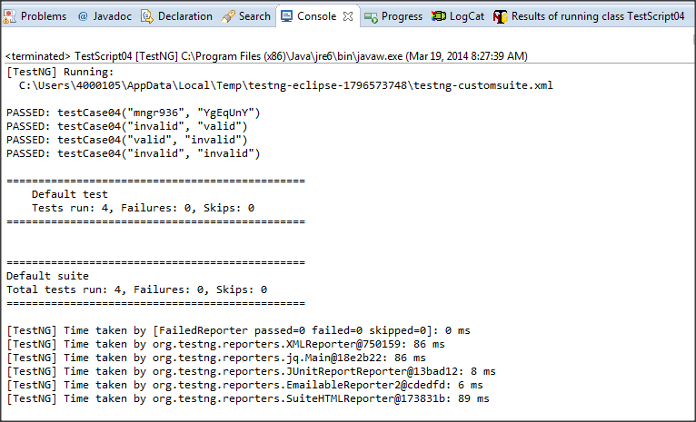

* You can see the output of test execution of TestNG at \AutoTest\test-output\index.html

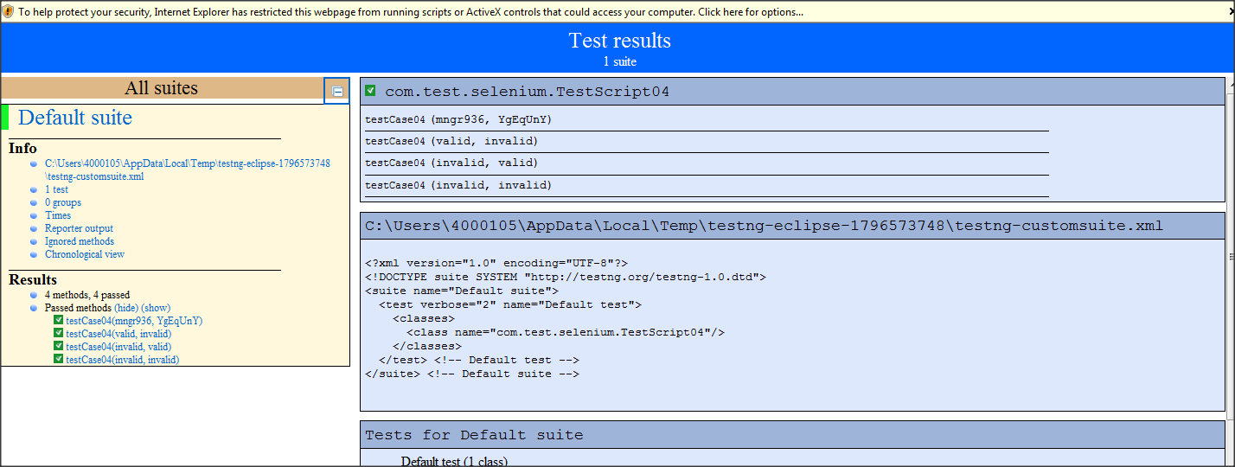

# Parameters to Change before Script Run

* The Test Script using FireFox to launch the website
* Open file Util.java change the path of FIREFOX_PATH parameter to your Firefox path on your PC



* Change the login credentials for Guru99 Bank in the same file.

